Transition from State of Emergency to Priority Measures to Prevent the Spread of Disease
As of Thursday, June 17, 2021

Emergency Measures being lifted
The national government’s task force decided to lift the State of Emergency Measures implemented on this prefecture Sunday, June 20.
The infection situation in Fukuoka prefecture, the number of new cases per 100,000 people in the last one week has decreased significantly (from 67.2 to 5.4) compared to the peak on Saturday, May 15, and has dropped to the equivalent of Stage 2 of the national index. The medical institutions has been strengthened sequentially, and the number of hospital beds has increased from the initial 1,049 to 1,403, exceeding the target of 1,220. Of these, the number of critical care beds has been increased from 111 to 201. As of Wednesday, June 16, the hospital bed occupancy rate was 30.4%, and the critical care bed occupancy rate decreased to 22.2%.
As a result of these improvements, the prefecture has been removed from the area where the state of emergency needs to be implemented. We would like to express my deepest gratitude to the many residents and businesses of the prefecture for their understanding and cooperation, despite our strict requests to refrain from unnecessary outings, closing businesses, and shorten business hours.
I would also like to express my gratitude once again to all the medical personnel who have been working on the front lines of the fight against COVID-19 with a strong sense of mission, as well as secure hospital beds, medical treatments, and examination services.

Transitioning to Priority Measures Preventing the Spread of Disease
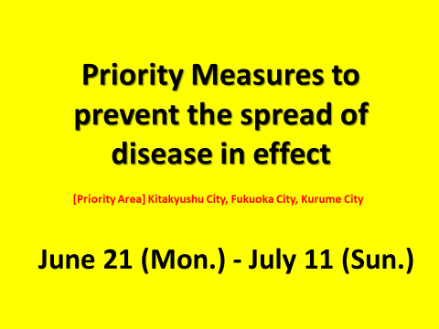
〇 Although the decision to be lifted from the state of emergency has been made, our prefecture still falls under Stage 3 in four indicators. In addition, our prefecture has a large population and a lot of human interaction. There is also a large downtown area, and the rebound of the infection in this prefecture would have a significant impact on the entire Kyushu-Yamaguchi region, so it is necessary to firmly control the infection.
The occupancy rate of hospital beds is still high at 22.2%, compared to 18% on Sunday, February 28, when the previous state of emergency declaration was lifted.
Mutated strains that are more infectious are being replaced by new mutated strains such as the "delta strain" that has been confirmed in Japan also poses a threat. Therefore, it is necessary to suppress the infection until we reach stage 2 or lower, and to be vigilant against the early re-spreading of the infection.
It is necessary to control infection from eating and drinking places where the risk of infection is considered high. Kitakyushu City, Fukuoka City, and Kurume City, the three major downtown areas in the prefecture. About 80% of the restaurants in the prefecture is concentrated in these three cities. As there are many customers from the surrounding areas, we must be extremely vigilant. Kitakyushu City, Fukuoka City, and Kurume City will be designated as priority areas for preventing the spread of the disease.
We have also decided on the measures of other areas of the prefecture and request it to all prefectural residents and businesses.
The period of the measures will be from Monday, June 21 to Sunday, July 11, in accordance with the national government decision.

[Requests to the Prefectural Residents]
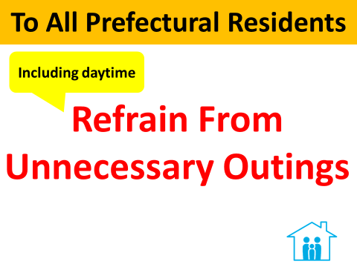
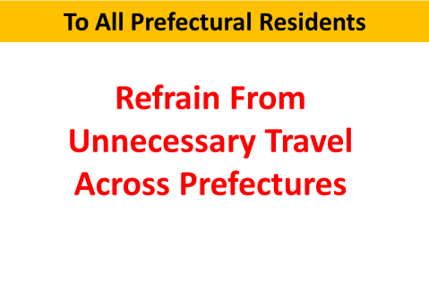
〇 Please refrain from unnecessary outings, including during the daytime. Please refrain from going out at night. Please refrain from traveling across prefectural borders, especially to and from prefectures that are in the state of emergency or priority measures are in effect in the area.
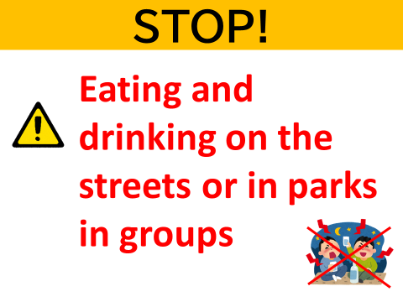
〇 Please refrain from eating and drinking in groups on the streets and in parks, and other activities that carry a high risk of infection. As for the prefectural parks, we will continue to take measures to prevent drinking in the parks.
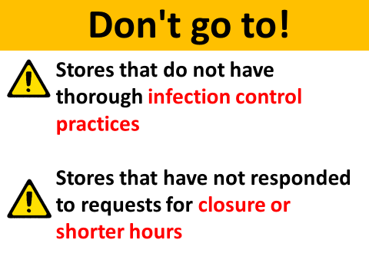
〇 Please refrain from going to restaurants after the requested hours of operation, and refrain from using restaurants that do not have thorough infection control measures in place or that have not responded to requests to shorten their business hours.
When going to restaurants, please limit the use to a small number of people and for a short period of time. When talking, please wear a mask and avoid loud voices.

[Request to Restaurants and Bars]
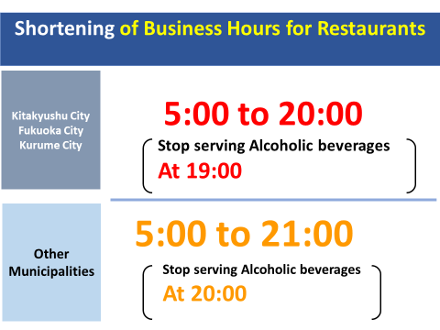
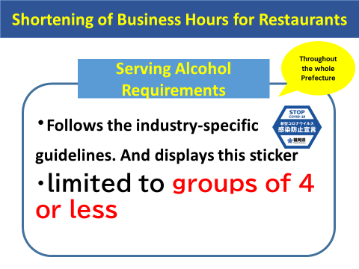
〇 The following is for Kitakyushu City, Fukuoka City, and Kurume City, which are in the "priority areas” The hours of operation should be between 5:00 and 20:00, with alcoholic beverages served from 11:00 and stop serving alcohol at 19:00.
Next, for cities and towns outside “priority zone," we request that the hours of operation be between 5:00 and 21:00, with alcoholic beverages served from 11:00, and the order stop at 20:00.
Alcoholic beverages may only be served at establishments that comply with industry-specific guidelines and displaying the "Infection Prevention Declaration Sticker" issued by Fukuoka Prefectural Government. When serving alcoholic beverages to patrons, only groups of four people or less are allowed.
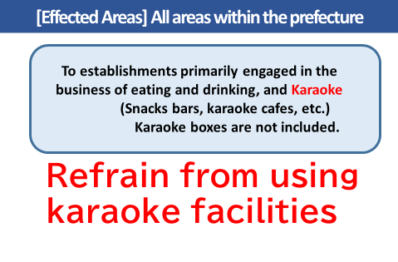
〇 Establishments such as snack bars and karaoke cafes that mainly serve food and beverages and provide karaoke are requested to refrain from using such equipment. Karaoke boxes are exempt from this rule.
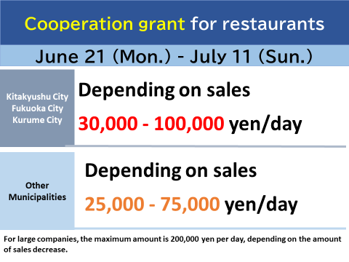

〇 Restaurants that cooperate with the request will be paid for their cooperation.
For small and medium-sized enterprises in the “priority zones”, 30,000 to 100,000 yen per day, depending on the amount of sales. Other small and medium-sized enterprises outside of the “priority zone” will receive 25,000 to 75,000 yen per day depending on their sales.
Large companies will receive up to 200,000 yen per day depending on the amount of decrease in sales.

[Request to facilities that attract visitors]
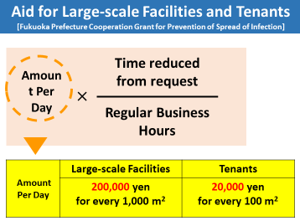
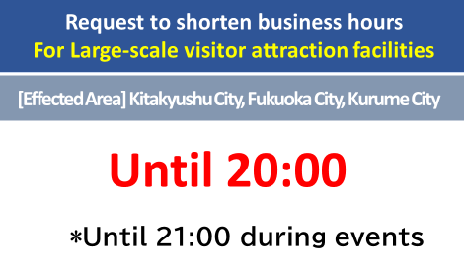

〇 For large scale facilities that attract visitors, such as those over 1,000 square meters, please keep the hours of operation from 5:00 to 20:00, and until 21:00 when events are held. Please ensure that visitors are organized and guided so that there is no congestion inside or outside the facility. Facilities and tenants that cooperate with us will be paid a grant for their cooperation.

[Limitation of holding events]
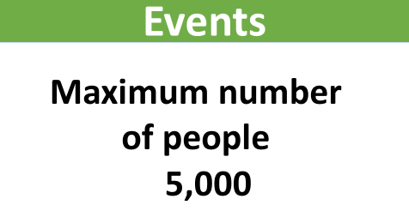
〇For events, the maximum number of people is set at 5,000. In the case of loud cheering or shouting, the maximum capacity shall be within 50% or 5,000 people, whichever is smaller.

[Regarding to Commuting to work]
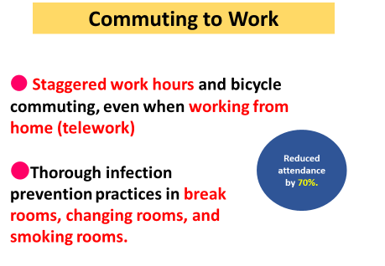
〇 We would like to ask businesses to continue to promote the use of work from home (telework) and vacation time with the aim of reducing the number of workers at work by 70%. Even if you do go to work, please strongly promote staggered work hours and other measures to reduce contact with other people.

[Guidelines to requests the national government to lift the priority measure zone]
〇 The period of the priority measures to prevent the spread of the disease is set to end on Sunday, July 11, but even within this period, if it is confirmed that the hospital bed occupancy rate and the critical care bed occupancy rate have shifted to Stage 2 or lower, we would like to request the government to lift the priority measures ahead of schedule.
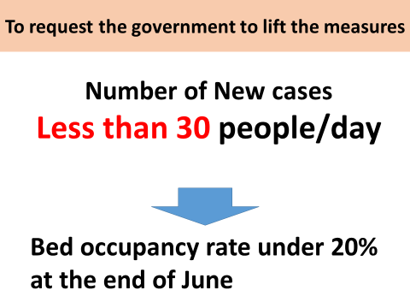
〇 If the number of new cases remains stable at 30 people, the rate is expected to reach 20% by the end of June.
Regarding the vaccine, the vaccination rate for the first round of vaccination for the elderly, which we are currently promoting, is 39.8%. To reduce the critical care beds occupancy rate, we will ensure that vaccination of the elderly, who are prone to severe diseases, is pursued.
During the period of priority measures starting from Monday, June 21, we will not relax, but will take thorough measures to prevent the spread of infection and prevent it from spreading again at all costs. We would like to ask for the understanding and cooperation of all residents and businesses in the prefecture.

