Extension of State of Emergency Declaration
英語（ENG）
Announced on Friday, May 28, 2021
As the national government extended the period of emergency measures today, a meeting of the prefectural government's coronavirus task force on was held to decide on the extension of the emergency measures and the details of the measures.
The extended period will be until Sunday, June 20. The content of the measures will continue to be the same as the previous measures.

【Request to the Prefectural Residents】
Please refrain from unnecessary outings, including during the daytime.
Please refrain from going out after 8pm.
Also, please refrain from unnecessary travel across prefectures.

Although the number of new cases is on the decline, we are concerned about an early rebound because highly infectious mutant strains that account for about 90% of the cases. Please stop and think carefully before going out, and act cautiously and responsibly.

【Requests to restaurants, bars, etc.】
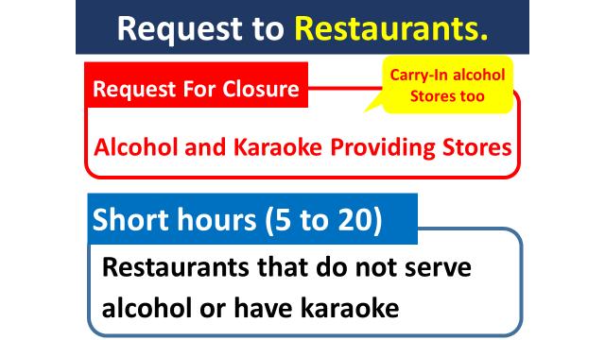
Restaurants, bars, and other establishments are requested to continue to refrain from serving alcoholic beverages and provide karaoke throughout the day, and to close or close their business hours between 5:00 and 20:00.
(Restaurants that allow users to bring their own alcoholic beverages inside are also requested to close.
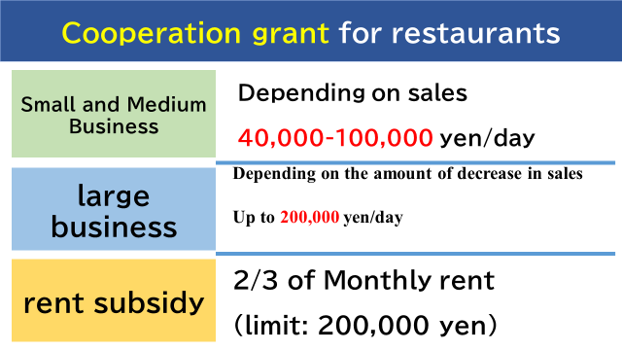
Restaurants that cooperate with us will be paid a cooperation grant.
In order to prevent infections caused by eating and drinking, we are currently warning to restaurants that do not respond to the request.
For those restaurants that do not respond to our request, we are considering "issuing an official order" under the Special Measures Law. We would like to ask for your cooperation to prevent this from happening.

【Requests to facilities that attract visitors】
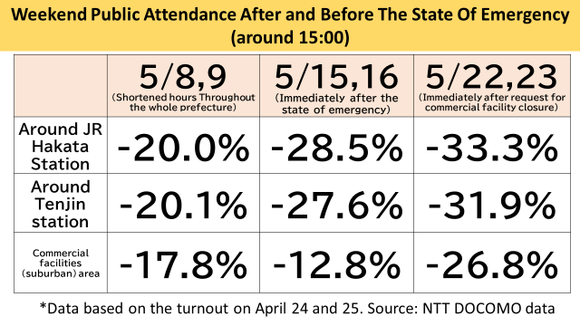
The following table shows the effect of the request for closure of facilities that attract visitors since last week on the number of visitors during the daytime on Saturday and Sunday before and after the state of emergency declaration.
The figures are compared based on the first Saturday and Sunday (April 24 and 25) when we requested people to refrain from unnecessarily outings and shorten business hours at restaurants.
The areas around Hakata Station and Tenjin subway station, the turnout has been decreasing with each step of the request.
In the area around suburban commercial facilities, the number of people increased immediately after the declaration of the state of emergency, but after the request for closure last week, the number of people decreased significantly. This trend was similar around suburban commercial facilities in the prefecture.
We would like to express our gratitude to the department stores and other commercial and visitor-attracting facilities for their cooperation.
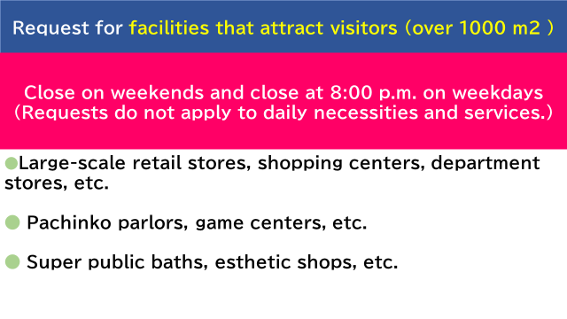
In order to ensure a decrease in the number of new cases, it is important to reduce the crowds.
We know this is a tough request, but we would like to ask you to continue to close commercial facilities that are over 1,000 square meters on Saturdays and Sundays and to shorten the hours of operation to 8 p.m. on weekdays, with the exception of stores selling daily necessities.
Other facilities that attract more than 1,000 square meters of visitors (movie theaters, gymnasiums, sports clubs, etc.) should be open until 20:00.
During events, the hours should be until 21:00, along with a limit on the number of visitors.
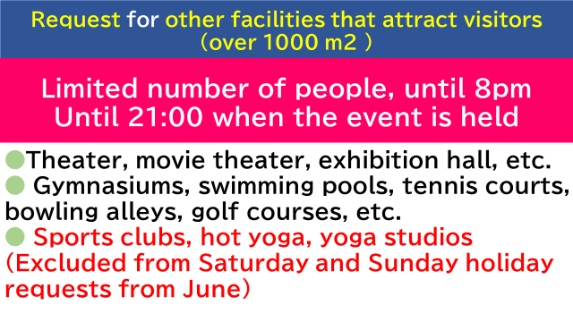

Due to a change in the national policy, sports clubs with an area of more than 1,000 square meters will not be requested to close on Saturdays and Sundays after June 1.
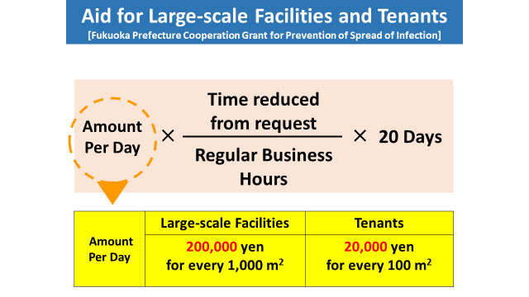
Businesses that respond to the request will be provided with cooperation grant.

【Commuting to the work, etc.】
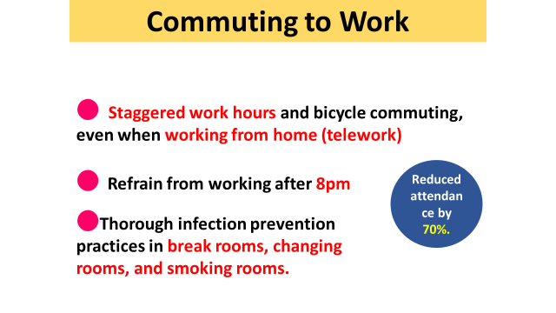
In order to achieve a 70% reduction in the number of employees coming to work, businesses are encouraged to promote the use of work from home (telework), promote the use of vacation days, and even when employees do come to work, strongly promote staggered work hours and other measures to reduce human contact.

【infection status】
○For the past 13 consecutive days, the number of visitors has been decreasing compared to the same day of the previous week, but it has remained high at around 200 people per day.
As of May 27, the hospital bed occupancy rate was 67.9%, and the critical care bed occupancy rate was 47.6% as of May 27.
The burden on the medical field has become too severe.
In addition, since more than 90% of the strains are highly infectious mutated strains, there is concern about an early rebound.

【Guideline for lifting of state of emergency.】
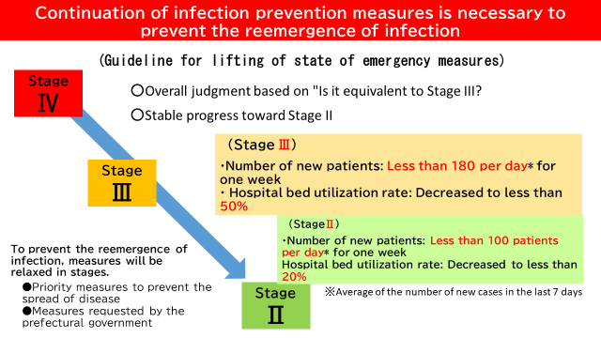
Regarding the lifting of the declaration, the government's basic response policy states that a comprehensive judgment will be made based on "whether it is equivalent to Stage III. Furthermore, in light of the spread of highly infectious mutant strains, it is necessary to make a more careful judgment by confirming whether or not the disease is stabilizing toward "Stage II.
Since there is a relationship between the number of new patients and the hospital bed utilization rate, we believe that among the national government‘s indicators, special emphasis should be placed on the number of new patients and the hospital bed utilization rate. In our prefecture, "Stage III" means that the number of new patients is 180 or less per day for one week, and the hospital bed utilization rate is less than 50%. Stage II" means that the number of new positive patients remains below 100 per day for one week, and the hospital bed utilization rate is below 20%.
We would like to make a decision after carefully assessing whether the situation is stable toward Stage II, and taking into account the opinions of experts.
We believe that the lifting of the state of emergency declaration is not the end of everything, but that until it is confirmed that the spread of the disease is under control, it is necessary to take measures for a certain period of time to prevent the reintroduction of the disease and to ease the situation in stages.

【Medical institution】
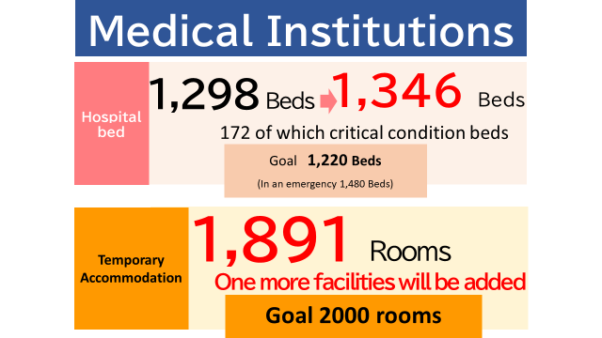
○ We have been increasing the number of beds for new corona patients from the 802 beds as of April 19 as needed.
Today, 48 new beds were secured, bringing the total number of beds to 1,346. Of these, 172 are critical care beds.
As for the accommodation treatment facilities, Green Rich Hotel Kurume (157 rooms) was opened today in Kurume City, bringing the total to nine facilities with 1,891 rooms.
With regard to hospital beds, we will continue to aim to secure 1,480 beds for emergencies and 2,000 rooms for temporary accommodations.

【Support for Home Nursing】
○ There are more than 2,700 patients who are currently receiving treatment at home, new support for daily life and medical care will be provided.
Regard to daily life support, free delivery of meals and other necessities will be commissioned to a private company starting June 1. For those receiving treatment at home who have difficulty in securing food, retort pouches, canned foods, soups, disinfectants, etc. will be delivered to supplement their daily diet.
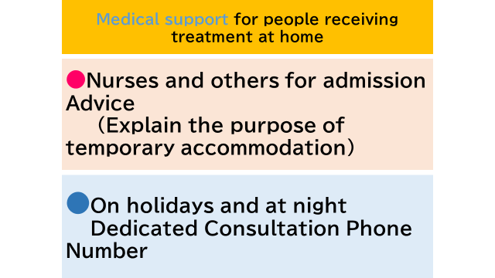
○ Regarding to medical support, nurses and public health nurses from the residential treatment advice team will carefully explain the benefits of residential treatment to those who are receiving treatment at home and have a high priority for medical care, such as those with underlying diseases, or those who have not agreed to residential treatment without special circumstances, and encourage them to enter the facility. This service is also scheduled to start on June 1.
In addition, we will open a dedicated number to introduce local medical institutions for examination and treatment of patients who are receiving treatment at home and present symptoms such as fever or fatigue at night or on holidays when the public health center is not available. We would like to start this service as soon as we can organize medical institutions.

【Vaccinations】
○ In January 2021, the prefectural government established the Vaccine Team within the prefectural government's coronavirus task force to support municipalities in vaccinating medical personnel and the elderly. The number of staff has been expanded to three groups with 16 members.
In the future, in order to support municipalities in vaccinating people other than the elderly, the prefectural government will need to consider setting up more wide-area vaccination centers to speed up the vaccination of prefectural residents. On June 1, a new organization, the Vaccine Promotion Office, was established in the Cancer and Infectious Diseases Disease Control Division, with a staff of 25, to study the target population for vaccination at the Regional Vaccination Center and the location of the center.
We will thoroughly implement emergency measures to contain the infection without any rebound. We apologize for any inconvenience and hardship this may cause to the citizens and businesses of the prefecture, and ask for your understanding and cooperation.

