英語（ENG）
Fukuoka Prefectural Government’s own measures to prevent the spread of COVID-19
May 3, 2021

Recently, the Fukuoka Prefectural Government made a request to Mr. Nishimura, Minister of State for Economic Revitalization, for the application of the "Priority Measures Preventing the Spread of Disease" to our prefecture. We are currently discussing with the national government the municipalities that will be affected and the duration of the measures. When we made this request, Minister Nishimura said, "We share a sense of crisis regarding the infection situation in Fukuoka Prefecture. We will deal with the request in a flexible manner," and we, the prefectural government have told him that would like to make this decision as soon as possible.

However, it will take a certain period before the "Priority measures preventing the spread of disease" is in effect. Based on the current infection situation in our prefecture, we have decided that strong measures such as the "Priority measures preventing the spread of disease" are necessary, and we need to take measures as soon as possible to stop the spread of the disease.
The prefectural government has decided to take the same measures as the "Priority measures preventing the spread of disease" ahead of others.
We would like to ask for the understanding and cooperation of all prefectural residents and businesses in the prefecture. (For details, please refer to "Future Response to the New Coronavirus Infection")
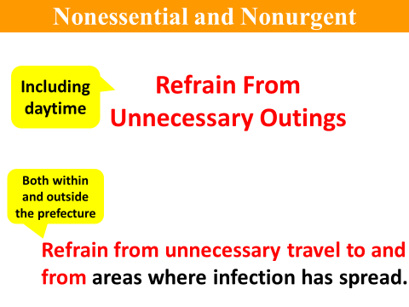
○ We ask that all prefectural residents continue to refrain from going out during the daytime, and refrain from unnecessary travel to and from areas where a state of emergency has been declared or where the infection has spread within the prefecture.
When going to dinner, whether at a restaurant or at home, please keep it in small number of people and no longer than 2 hours. Please wear a mask and avoid loud voices when talking. Please do not go in and out of restaurants without permission after the requested change in business hours, and refrain from eating and drinking in groups on the streets or in parks, as this increases the risk of infection.
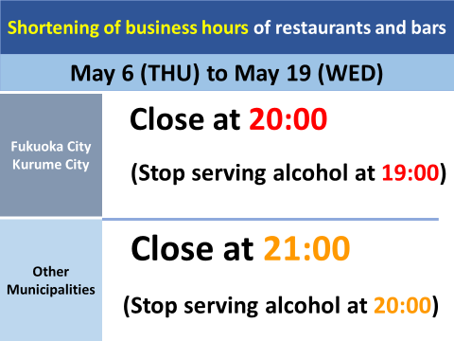
○ From Thursday, May 6 to Wednesday, May 19, we will ask restaurants in Fukuoka City and Kurume City to shorten their business hours from the current "until 21:00" to "until 20:00", which is one hour earlier than the current "until 21:00". Alcoholic beverages to be served from 11:00 a.m., and the stop serving alcohol at 7:00 p.m., or one hour before closing.
In addition to Fukuoka City and Kurume City, the infection has been gradually spreading in other parts of the prefecture, and the situation is unpredictable. Therefore, we would like to request that restaurants in all cities, towns, and villages other than Fukuoka City and Kurume City open from 5:00 to 21:00, serve alcoholic beverages from 11:00, and stop serving alcohol until 20:00.
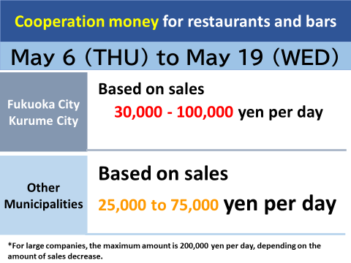
○ In the area of Fukuoka City and Kurume City, the amount is between 30,000 yen and 100,000 yen per day depending on the sales. In the area of Fukuoka City and Kurume City, the amount is between 30,000 yen and 100,000 yen per day, depending on the of sales.
In other cities, towns and villages, the amount is 25,000 yen to 75,000 yen per day.
For large companies, the same amount will apply throughout the prefecture, but the maximum amount will be 200,000 yen per day, depending on the amount of decrease in sales.
In addition, as a countermeasure the clustering of daytime karaoke, excluding karaoke boxes, we ask that you refrain from using karaoke facilities in places such as karaoke cafes and daytime snack bars.
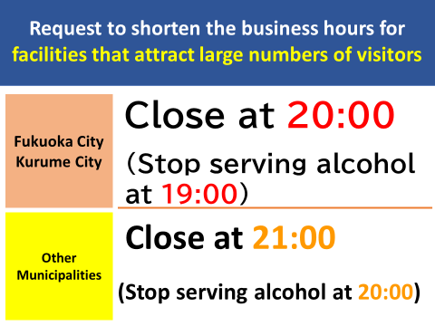
○ This is a request to all facilities that attract visitors. To ensure that prefectural residents to refrain from unnecessary outings, we would like to limit the number of people gathering at facilities and furthermore to limit the number of people eating and drinking. For theaters, movie theaters, exhibition halls, as well as commercial facilities of 1,000 square meters or more, exercise/playing facilities, museums, art galleries, etc., we request that the opening hours be limited to 20:00 in areas such as Fukuoka City and Kurume City, and to 21:00 in other municipalities.

○ The maximum capacity for the event is currently set at 10,000, but from Thursday, May 6 to Wednesday, May 19, the capacity will be 5,000. Please note that if loud cheering or shouting is expected, it should be within 50% of the capacity, whichever is smaller.

○ Although the current measures are to be taken until May 19, the duration of the measures will be determined again when the national government applies the priority measures to prevent the spread of the disease.
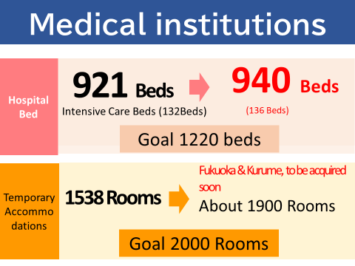
○ The prefectural government is working to strengthen its medical institutions. Today, we were able to secure 19 new hospital beds, bringing the total number of beds to 940. Of these, the number of beds for serious symptoms patients will increase by 4 beds, bringing the total to 136. As for temporary accommodation for recovery, one facility will be opened in Kitakyushu City on May 7. This will bring the total number of rooms to 1,538. We will continue to secure for two more temporary accommodations in Fukuoka City and Kurume City. If we can open these facilities, we will be able to secure about 1,900 rooms.
We apologize for the inconvenience this will cause to prefectural residents and businesses of the prefecture. To stop the spread of the COVID-19 infection at all costs, we sincerely ask for your understanding and cooperation.

To all prefectural residents, the future spread of COVID-19 depends on our current actions. Our current actions will determine what Fukuoka Prefecture will look like in 10 days or 2 weeks from now. To protect the lives of all residents of Fukuoka Prefecture and their loved ones, we would like to once again ask you to act carefully and responsibly.

