Strengthening Emergency Measures and
Establishment of Regional Vaccination Center for COVID-19 in Fukuoka Prefecture

Thursday, May 20, 2021

Eight days have passed since the start of the state of emergency. I would like to express my deepest gratitude to the many prefectural residents and businesses for their understanding and cooperation, despite our strict requests to refrain unnecessary outings and to close or shorten business hours.

At the meeting with the prefectural coronavirus task force, it was decided to request that facilities that attract a large number of people be closed on weekends.
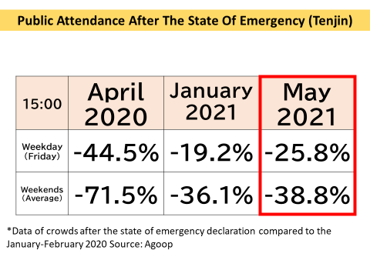
〇 Regarding the number of people going out, both weekdays and weekends have decreased compared to the time when the state of emergency was declared in January, but there has been a significant increase since the time when the state of emergency was declared last April.

The number of new cases reached a record high of 634 on Wednesday, May 12, and has remained at an extremely high number of cases, reaching 500 on Wednesday, May 19, although it has been decreasing for the past four days compared to the same day of the previous week.

As for the medical institutions, the hospital bed occupancy rate was 77.5% as of Wednesday, May 19, and the critical care bed utilization rate was 52.5%.

Although there is no cases of people who need immediate hospitalization cannot be hospitalized, the peak in the number of hospitalized people tends to come later than the peak in the number of new cases.

If the current infection trend continues, we are concerned that this situation will become very serious.

The current wave of infections is much larger than the previous one, and the new mutated strains are more infectious than the previous strain, so it is necessary to reduce the number of people going out even further.

To end these emergency measure at all, we have decided on new measures for facilities that attract a large number of people.

[New Measures]
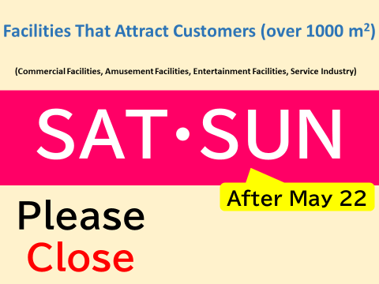
〇 Facilities that are more than 1,000 m² , specifically

- Commercial facilities (excluding daily necessity services), such as department stores and shopping centers
- Amusement facilities" such as pachinko parlors and game centers, "Entertainment facilities"
- Horse races, boat races, and off-track ticket offices, etc.
- Super public baths and beauty salons type of service industry (excluding daily necessity services)

In addition to shortening the business hours to 8:00 p.m. during the period of emergency measures, we request that these facilities be closed on Saturdays and Sundays after May 22 (Saturday). Those facilities that cooperate with us will be compensated for their cooperation.

For those facilities that are not subject to this program, please make sure to organize and guide visitors to avoid congestion inside and outside the facilities.

[Reduce Work Commuters]

To reduce the number of workers going to the office, it is also important to ensure that employees work from home.

Businesses are encouraged to strongly promote work from home (telecommuting), staggered work hours, and other measures to reduce human contact, with the aim of reducing the number of workers at work by 70%.

With the exception of employees engaged in work that is essential to protect the lives and property of the prefectural residents, such as countermeasures against COVID-19 and work at child guidance centers, The prefectural government has also been working to reduce the number of employees commuting to the office by work from home, taking leave, etc.

As of Friday, May 14, 67.5% of employees were working from home, a reduction of nearly 70%. We would like to ask all businesses to cooperate with us in this effort.

〇 By requesting department stores, pachinko parlors, etc. to close on Saturdays and Sundays, there are concerns that people will go to neighboring prefectures to use their stores. At the Kyushu Governors' Meeting, we agreed with the governors of each prefecture to refrain from unnecessary and unnecessary travel across prefectural borders.

We would like to ask all prefectural residents to refrain from unnecessary travel across the border of the prefecture.
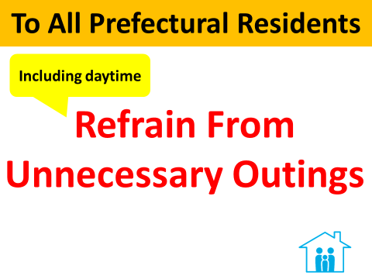
〇 In addition, please continue to refrain from unnecessary outings, including during the daytime. Even if you do go out, please stop and think about whether it is really necessary at this time, and act prudently and responsibly as a member of society.

[Medical Institutions]
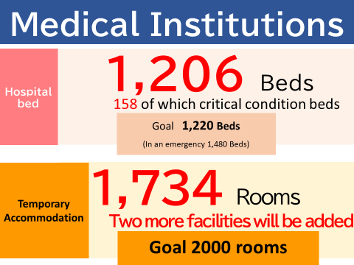
〇 The prefecture government has increased the number of hospital beds for COVID-19 patients from 802 as of Wednesday, April 19, as needed, and currently has 1,206 beds available. Of these, the number of beds for critical conditions has been increased from 111 to 158.

Two new temporary accommodation facilities have been opened since May, with a total of 1,734 rooms.

As for hospital beds, we will secure the target of 1,220 beds and 1,480 beds for critical conditions. We aim to secure a target of 2,000 rooms for temporary accommodation facilities.
[Fukuoka Prefecture Regional Vaccination Center]
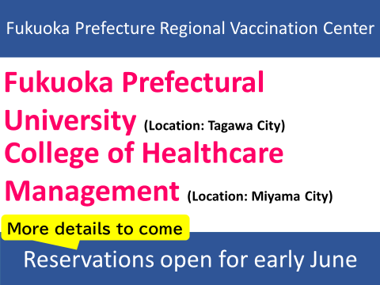
〇 The vaccine, which is expected to be a trump card against COVID-19, municipalities are aiming to finish vaccinating the elderly by the end of July.

The prefectural government has decided to set up two "Fukuoka Prefecture Regional Vaccination Centers" so that all elderly people living in the prefecture who wish to be vaccinated can do so by the end of July.

The venues are "Fukuoka Prefectural University" in Tagawa City and "College of Healthcare Management " in Miyama City.

Both venues have the capacity to inoculate up to 1,000 people per day, and two doses of the Moderna vaccine will be given.

Eligibility will be elderly people in municipalities who have difficulty completing vaccinations by the end of July, or who have requested the establishment of mass vaccination sites, and we plan to secure transportation to the sites.

We are currently preparing so that we can start accepting reservations in early June. Details will be announced later.

We apologize for any inconvenience and hardship this may cause, and ask for your understanding and cooperation in preventing the spread of the infection.

