“Fukuoka Corona Alert” and the counter measures for the future
英語
August 5th 2020
Fukuoka Prefectural Government
〇 New cases of COVID-19 was up to 170, which was an all time high and the spread of the infection does not seem to slow down.
〇 The percentage of patients that do not know how they got infected is over 50% , and the number of people with serious and mild symptoms are increasing.
〇 With all of these past events in mind, we have concluded to issue a “Fukuoka Corona Alert”
〇 In response to this, for the medical service system, we will once again request medical institutions to prepare for hospital beds and we will also need to accelerate securing of accommodation for medical treatment facilities.
〇 Then, we will make new requests to prefectural residents and businesses.
〇 Since July, there were 25 facilities where clusters occurred in this prefecture, about half of them are “Restaurant with close contact” and “Restaurant that serve alcohol”. Therefore, the requests are aimed mainly towards these stores.
〇 A general request first. Please show that the restaurants with close contact, restaurants that serve alcohol, and karaoke shops in the prefecture to comply with industry guidelines and have infection prevention measures. Please use the sticker that is used by all prefectures to display that you are following the guidelines.
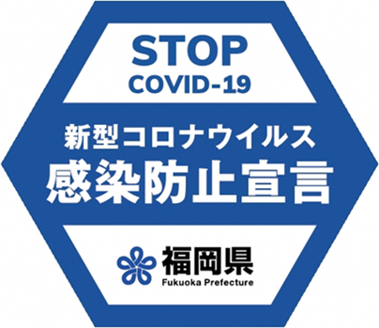

〇 From August 8th to 21st, including Obon, I encourage guests to keep their stay in these restaurants within 2 hours.
〇 Next is a request for cooperation of closures. About 60% of cases are from Fukuoka City. We request the cooperation of the entertainment facilities stipulated by the Special Measures Law Enforcement Ordinance, "restaurants with close contact", " restaurants and karaoke places that serve alcohol " that do not comply with the industry-specific guidelines for the closure from 8th to 21st August.
〇 Next, I would like to ask all prefectural residents, to refrain from going to these establishments that do not comply with these guidelines. Also, from August 8th to 21st, even if the establishment complies with the guidelines, please stay within 2 hours and refrain from going to anther establishment afterwards.
英語
〇 Any further spread of infection must be prevented. I want you to be very conscience of your actions and think that you might be infected and to be conscience to “not infect people” and “not get infected from people”.
〇 If the infections cannot be stopped and there is a fear that it will overwhelm the medical service system, it will be unavoidable to issue stricter measures.
〇 I ask for prefectural residents and business owners’ complete understanding and cooperation.

