Regarding to the “Fukuoka COVID-19 Alert” and from now on
英語

August 20th
Fukuoka Prefectural Government

From the middle of July and on, new cases of COVID-19 infections and cases of unknown transmission have been increasing and the occupancy rate of hospital beds have been increasing too. On August 5th we have set up the Fukuoka COVID-19 alert, based on the status of the clusters, we requested to improve the medical support system, we have requested new measures for prefectural residents and businesses to follow.
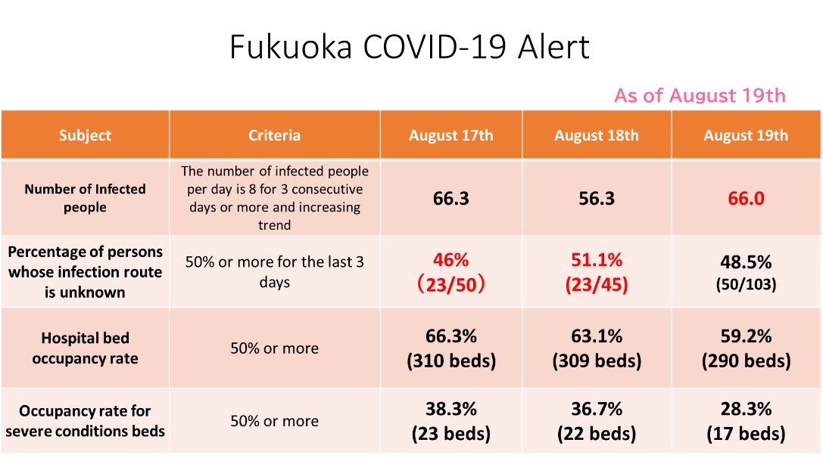
The occupancy rate of hospital beds has gradually increased since August 5, and the situation is still unpredictable. As a result, the "Fukuoka COVID-19 Alert" will continue to be in effect; however, the number of new infections has been decreasing and the number of clusters at restaurants and other facilities where they have been cooperating with the request has been decreasing. If this trend continues, the strain on the healthcare system would decrease too.

As we will have to face with COVID-19 for a long time to come, it will be difficult to maintain prevention measures, such as requesting to people and businesses to temporary close or refraining from going outside for a long period of time, so it is important for society as a whole to prevent infections.
For this reason, we are reviewing the cooperation of the requests we have made to prefectural residents and businesses based on the current situation, while reducing the restrictions on socioeconomic activities as much as possible, on the basis of infection prevention, and will provide new support to businesses cooperating with infection prevention measures.
If the spread of the infection progresses even further and it becomes difficult to maintain and ensure the provision of medical care, we will once again ask the citizens and businesses of the prefecture to take further measures.
1. Cooperation request to prefectural residents after August 22
英語
To the prefectural residents
Refrain from using restaurants, etc.* that do not comply with the guidelines. To determine whether or not they are in compliance, check the prefectural government's " Infection Prevention" sticker, which indicates that the restaurant is working on infection prevention measures.
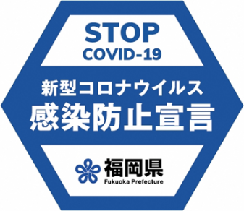

In addition, the following requests for the period August 8-21 will be cancelled.
No more than 2 hours of meals and drinking, etc., and refrain from after-parties and third parties.
※ (1) Among the entertainment facilities stipulated in Article 11, Paragraph 11, Item 11 of the Order for Enforcement of the Act on Special Measures against Pandemic Influenza, etc.
Restaurants with close contact (those involving the close contact with customers regardless of title)
Restaurants (bars, nightclubs, etc.) that serve alcoholic beverages
Karaoke places that serve alcoholic beverages
(2) Other restaurants that serve alcoholic beverages (e.g. pubs)

A general request in light of the recent outbreaks
In light of the recent outbreaks of clusters in schools and educational facilities, young people are urged to exercise caution in order to avoid spreading the virus to the elderly and others who are more susceptible to severe infection through infections at home.
Refrain from eating or drinking with large groups of people especially when the number of people, the size of the venue, and the ventilation, etc. are not taken into account to prevent infection.
Refrain from using day care facilities (day service) if symptoms such as fever are seen there, and if a cluster is occurring.

